**Case study – Creation of user stories and test cases & bug report**

**Github link: https://github.com/Aranyaa-k/Final-Case-Study.git**

**User Story 1:**

TERMINATION REASONS

As a user when I go to “Termination Reasons” under “configuration” toggle under “PIM” tab then I should be able to add, edit and delete the termination terms of any employee.

**Acceptance Criteria:** When valid credentials are entered and select “Termination Reasons” page then:

* User should be able to add “Termination Reason” to the list.
* User should be able to edit the “Termination Reason” record of the employee.
* User should be able to delete the “Termination Reason” record of any employee.

Priority: 1

Effort: 4

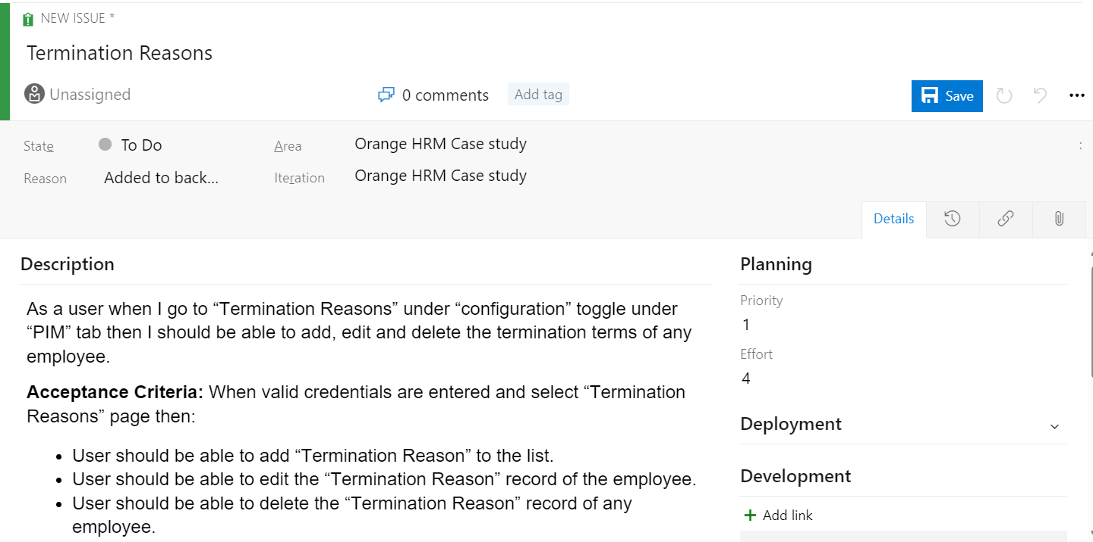

**Test case for user 1:**

TC_001:

Description**:** To validate the functionality of the “Add” button

Given the user is logged in to the website “https://opensource-demo.orangehrmlive.com/web/index.php/auth/login” in chrome web browser using the valid username “Admin” and valid password “admin123” and he is in the “Termination Reasons” tab under “Configuration” dropdown in “PIM” tab.

When the user clicks on the “Add” button

Then the user should be redirected to the page (https://opensource-demo.orangehrmlive.com/web/index.php/pim/saveTerminationReasons) which asks the user to type in the termination reason.

TC_002:

Description: To validate the functionality of “Cancel” button on adding to the list on “Termination Reasons”.

Given the user is logged in to the website “https://opensource-demo.orangehrmlive.com/web/index.php/auth/login” in chrome web browser using the valid username “Admin” and valid password “admin123” and in the “Add” page in “Termination Reasons” tab under “Configuration” dropdown in “PIM” tab.

When the user clicks on the “Cancel” button

Then the user should be redirected to the previous page (<https://opensource-demo.orangehrmlive.com/web/index.php/pim/viewTerminationReasons>)

TC_003:

Description: To check whether the Termination Reason input field in accepting text input.

Given the user is logged in to the website “https://opensource-demo.orangehrmlive.com/web/index.php/auth/login” in chrome web browser using the valid username “Admin” and valid password “admin123” and in the “Add” page in “Termination Reasons” tab under “Configuration” dropdown in “PIM” tab.

When the user clicks in the text field

Then the text field should accept user input

TC_004:

Description: To validate the functionality of “Save” button on adding to the list on “Termination Reasons”.

Given the user is logged in to the website “https://opensource-demo.orangehrmlive.com/web/index.php/auth/login” in chrome web browser using the valid username “Admin” and valid password “admin123” and in the “Add” page in “Termination Reasons” tab under “Configuration” dropdown in “PIM” tab.

When the user clicks on the “Save” button after adding the valid input

Then the inputshould be added to the list and the user should be redirected to (https://opensource-demo.orangehrmlive.com/web/index.php/pim/viewTerminationReasons)

TC_005:

Description: To validate the functionality of checkbox in the ‘Termination Reasons’ List

Given the user is logged in to the website “https://opensource-demo.orangehrmlive.com/web/index.php/auth/login” in chrome web browser using the valid username “Admin” and valid password “admin123” and in the “Add” page in “Termination Reasons” tab under “Configuration” dropdown in “PIM” tab.

When the user clicks on the checkbox of the termination reason in the list

Then the user should be able to select that specific item from the list on which further functions can be performed that is deletion and updation.

**Bug Report:**

* **Description of bug:** Login successful with invalid credentials
* **Steps to reproduce:** Open OrangeHRM in chrome browser, enter “admin” username and “admin123” password and click on login button. The user is able to successfully login
* **Time stamp:** 06/09/2024 12:50 PM
* **Severity: High**
* **Priority:** Major
* **Assignee:** Developer3
* **Screenshot**
* 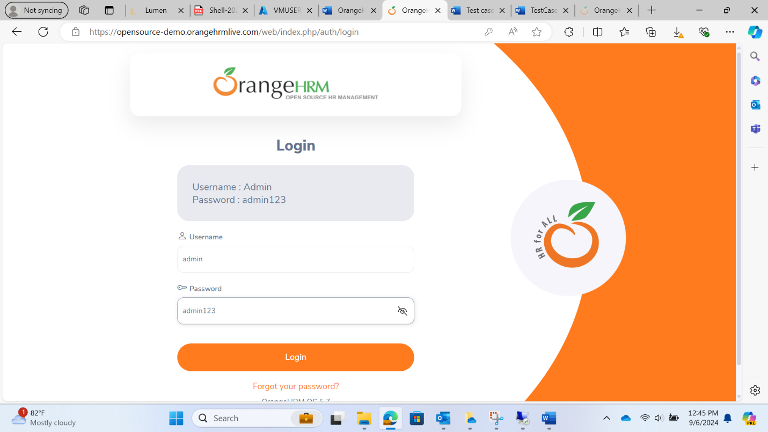
* 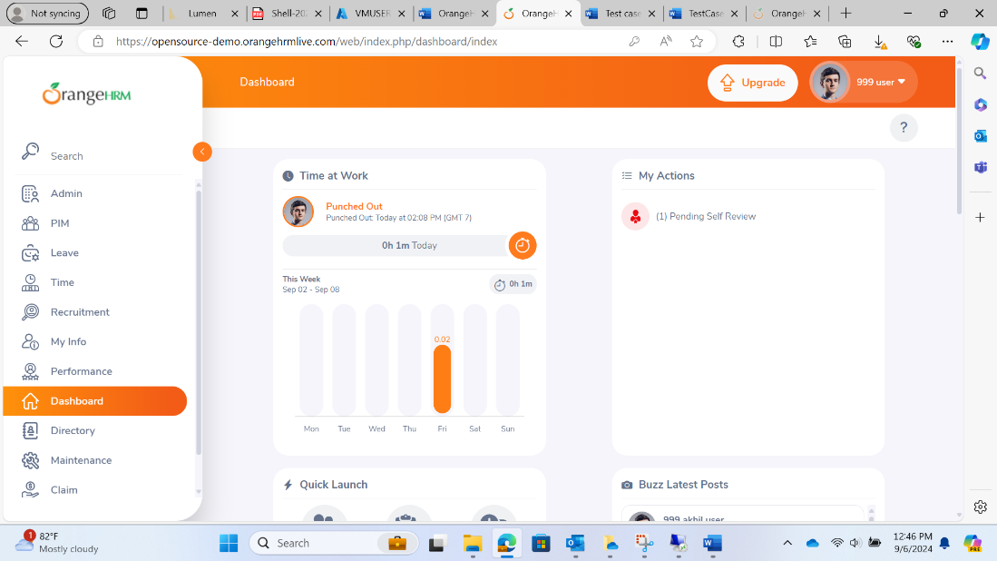

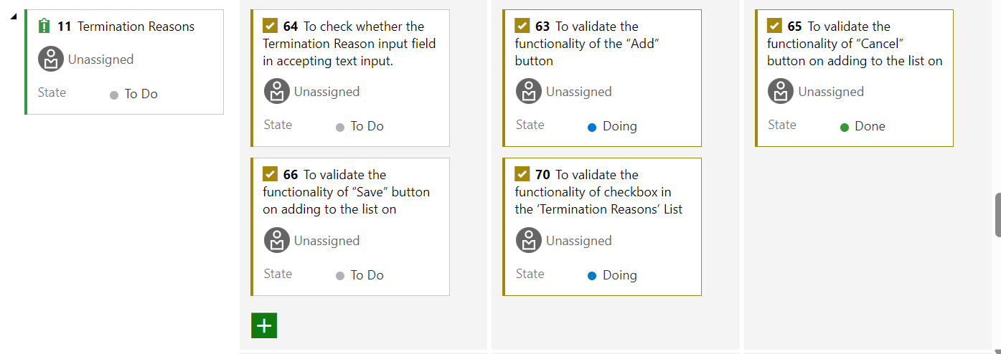

**User story 2:**

As a user when I go to Vacancies option in the Recruitment tab, then I should be able to Add, Edit, Search and Delete vacancies.

Acceptance Criteria: When user goes to the Vacancies option in Recruitment, the system should.

* Allow the user to search for existing vacancies.
* Allow the user to add vacancies.
* Allow user to view details of existing vacancies.
* Allow user to delete vacancies.

Priority: 2

Effort: 4

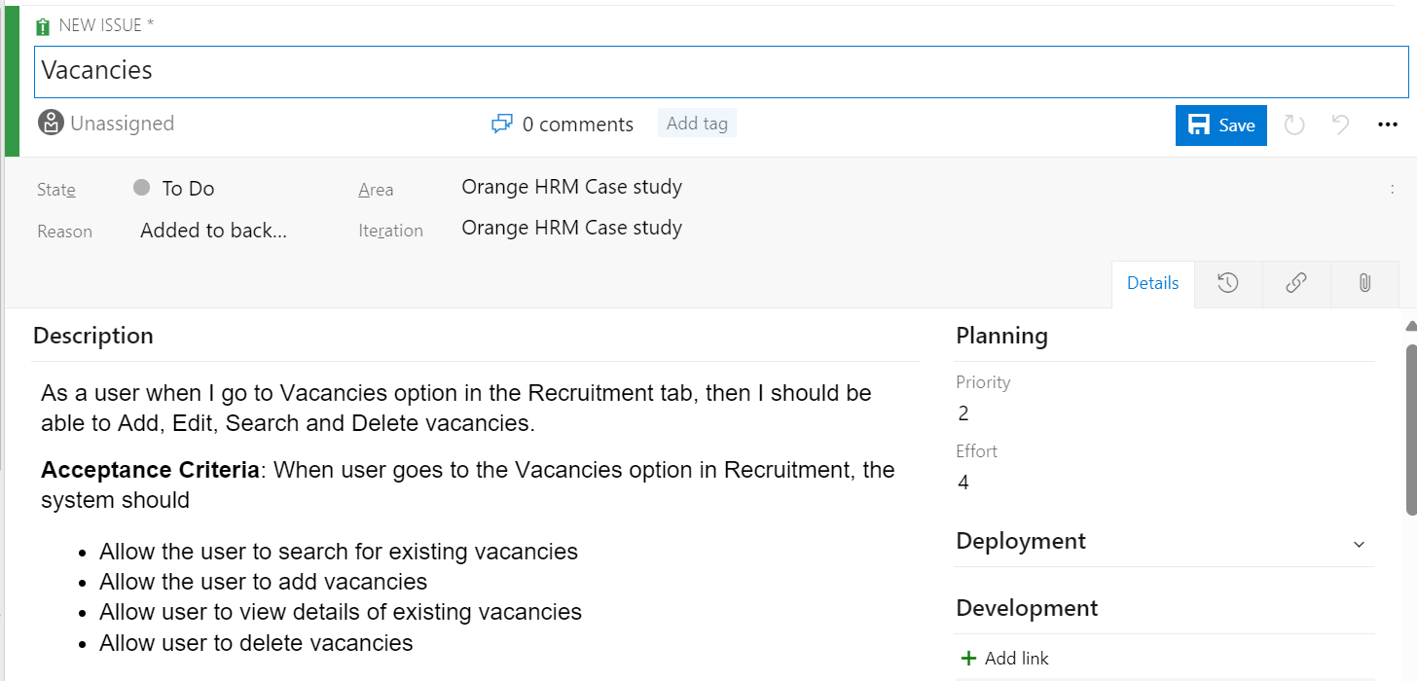

TC_006:

Description: To validate the search functionality for Vacancies under Recruitment tab

Given the user is able to access the website “OrangeHRM (orangehrmlive.com)” in chrome browser and logged in using username “Admin” and password “admin123” and currently on the vacancies page in recruitment tab

When the user enters search criteria in the search field

And clicks the "Search" button

Then the system should display a list of vacancies matching the search criteria

TC_007:

Description: To validate the add functionality for Vacancies under Recruitment tab

Given the user is able to access the website “OrangeHRM (orangehrmlive.com)” in chrome browser and logged in using username “Admin” and password “admin123” and currently on the vacancies page in recruitment tab

When the user clicks the "Add" button, fills in the vacancy details

And clicks the "Save" button

Then the system should display a confirmation message

And the new vacancy should appear in the list of vacancies

TC_008:

Description: To validate the bulk deletion of Vacancies under Recruitment tab

Given the user is able to access the website “OrangeHRM (orangehrmlive.com)” in chrome browser and logged in using username “Admin” and password “admin123” and currently on the vacancies page in recruitment tab

When the user selects multiple vacancies for deletion

Then the system should bulk delete all the entries and give confirmation message.

TC_009:

Description: To validate the edit functionality for Vacancies under Recruitment tab

Given the user is able to access the website “OrangeHRM (orangehrmlive.com)” in chrome browser and logged in using username “Admin” and password “admin123” and currently viewing a vacancy's details

When the user clicks on the Edit icon for a vacancy, updates the vacancy's details

And clicks the "Save" button

Then the system should display a confirmation message

And the updated details should be reflected in the vacancy's profile

TC_010:

Description: To validate the delete functionality for Vacancies under Recruitment tab

Given the user is able to access the website “OrangeHRM (orangehrmlive.com)” in chrome browser and logged in using username “Admin” and password “admin123” and currently on the vacancies page in recruitment tab

When the user clicks on the delete icon for a vacancy

And confirms the deletion

Then the system should display a confirmation message

And the vacancy should be removed from the list of vacancies

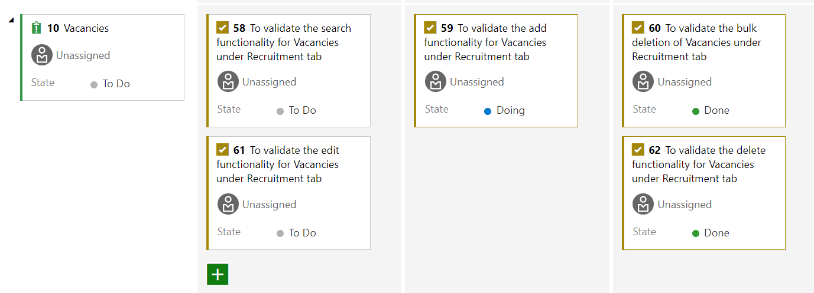

**User Story 3:**

**Title:** Reporting Method Functionality

As a user, when I go to PIM tab, select Configuration and click on Reporting Methods, I should be redirected to a page where I can add new reporting methods, delete and edit existing reporting methods.

**Acceptance criteria:** When user clicks on Reporting Methods:

* Should be redirected to view reporting methods page
* Should be able to new reporting methods
* Should be able to edit and delete existing reporting methods

Priority: 4

Effort: 5

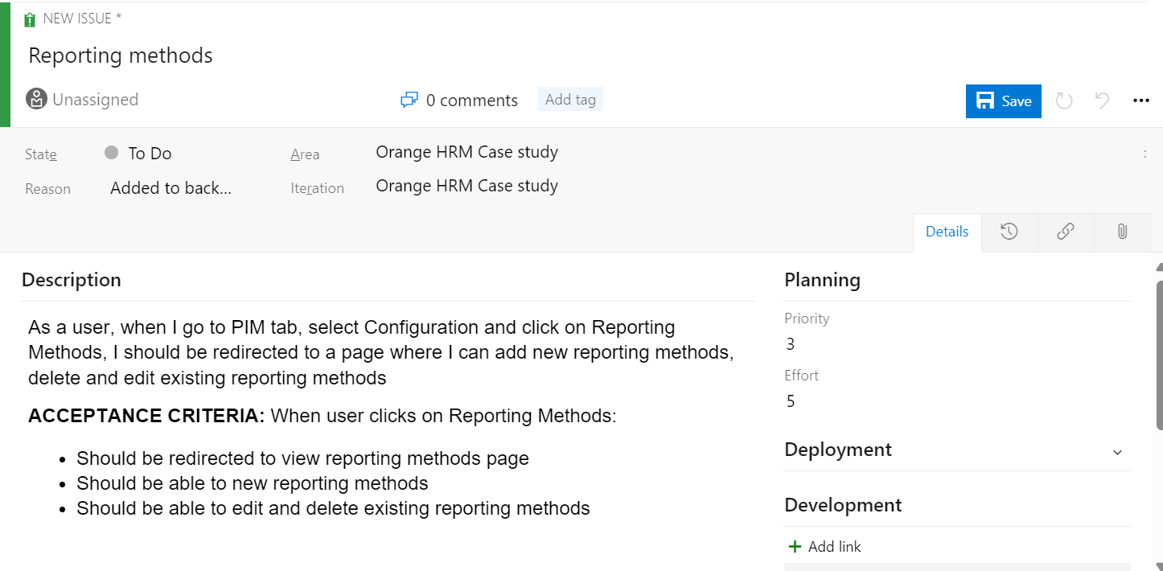

**Test cases:**

TC_011:

Description**:** To validate if the user is redirected to Reporting Methods page

Given the user is logged in to the website [OrangeHRM (orangehrmlive.com)](https://opensource-demo.orangehrmlive.com/web/index.php/auth/login) using the valid username “Admin” and valid password “admin123”

When user clicks on PIM tab -> Configuration Drop down -> Reporting Methods

Then user should be navigated to Reporting Methods page <https://opensource-demo.orangehrmlive.com/web/index.php/pim/viewReportingMethods> 

|  |  |  |  |
| --- | --- | --- | --- |
| S. No. | Page Name | Page accessibility (Pass/Fail) | |
| Actual | Expected |
| 1 | Reporting Methods | Pass | Pass |

TC_012:

Description**:** To validate if the user is redirected to save reporting method page

Given the user is on the Reporting Methods page <https://opensource-demo.orangehrmlive.com/web/index.php/pim/viewReportingMethods>And user clicks on the Add buttonThen the user should be redirected to Save reporting method page <https://opensource-demo.orangehrmlive.com/web/index.php/pim/saveReportingMethod>

|  |  |  |  |
| --- | --- | --- | --- |
| S. No. | Page Name | Page accessibility (Pass/Fail) | |
| Actual | Expected |
| 1 | Save Reporting Method | Pass | Pass |

TC_013:

Description**:** To validate if the user is able to add a new reporting method

Given the user is on the Save reporting method page <https://opensource-demo.orangehrmlive.com/web/index.php/pim/saveReportingMethod>

When user writes a new reporting method in the Name field

And clicks on the Save button

Then the new reporting method should get added the reporting methods list

|  |  |  |  |
| --- | --- | --- | --- |
| S. No. | New reporting method | New reporting method getting added (Pass/Fail) | |
| Actual | Expected |
| 1 | Test Report | Pass | Pass |

TC_014:

Description**:** To validate if the user is able to delete an existing reporting method

Given the user is on the Reporting Methods page <https://opensource-demo.orangehrmlive.com/web/index.php/pim/viewReportingMethods>When the user clicks on the delete icon of any reporting method except Direct (as it is always in use)

And clicks on the Yes, Delete button  
Then that reporting method should be deleted from the reporting methods

|  |  |  |  |
| --- | --- | --- | --- |
| S. No. | Reporting method | Reporting method getting deleted (Pass/Fail) | |
| Actual | Expected |
| 1 | Indirect | Pass | Pass |
| 2 | Test Report | Pass | Pass |

TC_015:

Description**:** To validate if the user is able to edit an existing reporting method

Given the user is on the Reporting Methods page <https://opensource-demo.orangehrmlive.com/web/index.php/pim/viewReportingMethods>When the user clicks on the edit icon of any reporting method

And writes the new name of that reporting method and clicks on Save button

Then that reporting method’s name should be edited

|  |  |  |  |
| --- | --- | --- | --- |
| S. No. | Reporting method | Reporting method getting deleted (Pass/Fail) | |
| Actual | Expected |
| 1 | Direct | Pass | Pass |
| 2 | Indirect | Pass | Pass |
| 3 | Test Report | Pass | Pass |

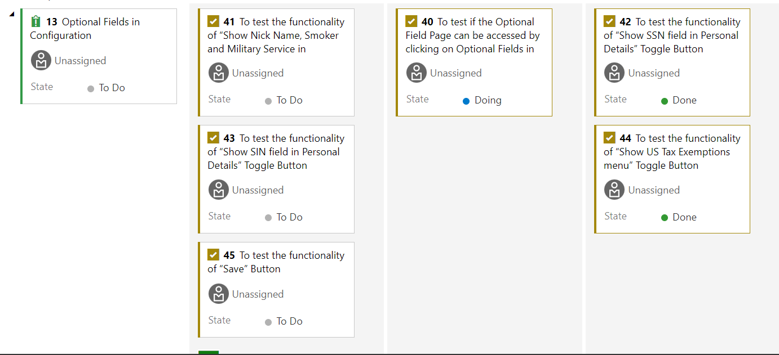

**User story 4:**

Create New User

As a new user, I want to create a new user in the system,   
so that the new employee can access the OrangeHRM application with appropriate permissions.

**Acceptance Criteria:**

* Given I am logged in as an Admin, when I navigate to the User Management section, then I should see an option to add a new user.
* Given I am on the Add New User page, when I enter the required details (e.g., username, password, employee name, user role, status), then I should be able to save the new user.
* Given I have entered all required details correctly, when I click the ‘Save’ button,   
  then the new user should be created and listed in the User Management section.
* Given I have created a new user, when I navigate back to the User Management section, then I should see the new user in the list with the correct details.

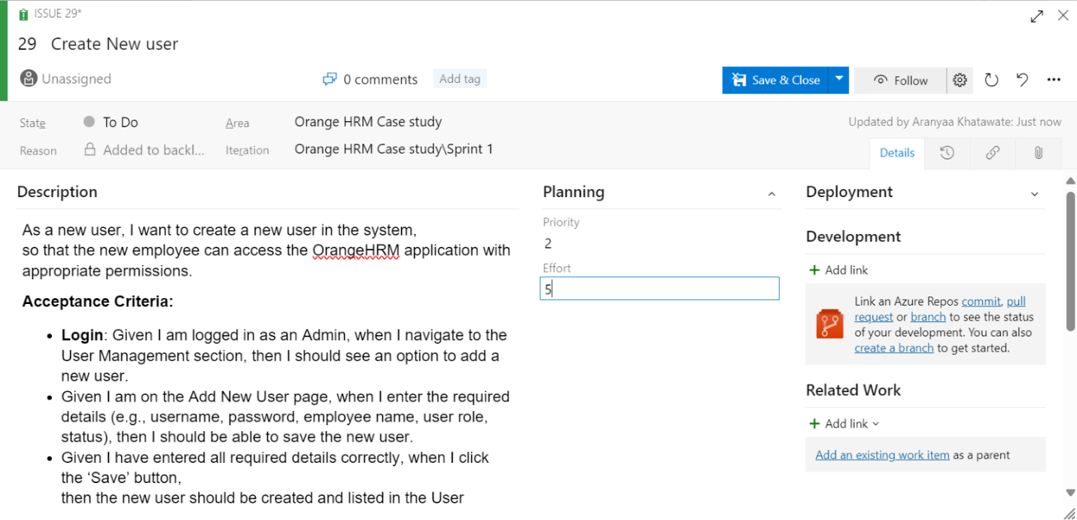

**Test cases:**

**TC_016: Verify Admin Can Access Add New User Page**

Description: To test if the Admin can access the Add New User page.

Given the Admin can access the OrangeHRM application and logs in using admin username and admin_password password,   
When the Admin navigates to the User Management section and clicks on the “Add New User” button,   
Then the Admin should be able to view the Add New User page.

**TC_017: Verify New User Creation with Valid Data**

Description: To test if a new user can be created with valid data.

Given the Admin is on the Add New User page,   
When the Admin enters valid data (Username: jdoe, Password: Password123!, Employee Name: John Doe, User Role: ESS, Status: Enabled) and clicks the “Save” button,   
Then the new user should be created successfully and listed in the User Management section with the correct details.

**TC_018: Verify Unique Username Validation**

Description: To test the validation for unique usernames.

Given the Admin is on the Add New User page,   
When the Admin enters a username that is already in use (Username: existing_user, Password: Password123!, Employee Name: Jane Smith, User Role: Admin, Status: Enabled) and clicks the “Save” button,   
Then the system should display an error message indicating that the username is already taken.

**TC_019: Verify Password Complexity Requirements**

Description: To test the password complexity requirements.

Given the Admin is on the Add New User page,   
When the Admin enters a password that does not meet complexity requirements (Username: newuser, Password: simple, Employee Name: Alice Johnson, User Role: ESS, Status: Enabled) and clicks the “Save” button,   
Then the system should display an error message indicating that the password does not meet the security requirements.

**TC_020: Verify User Role Assignment**

Description: To test if the user role is assigned correctly.

Given the Admin is on the Add New User page,   
When the Admin enters valid data (Username: mnguser, Password: Password123!, Employee Name: Bob Brown, User Role: Manager, Status: Enabled) and clicks the “Save”

button,   
Then the new user should be listed with the correct user role (Manager) and should have the appropriate permissions based on the assigned role.

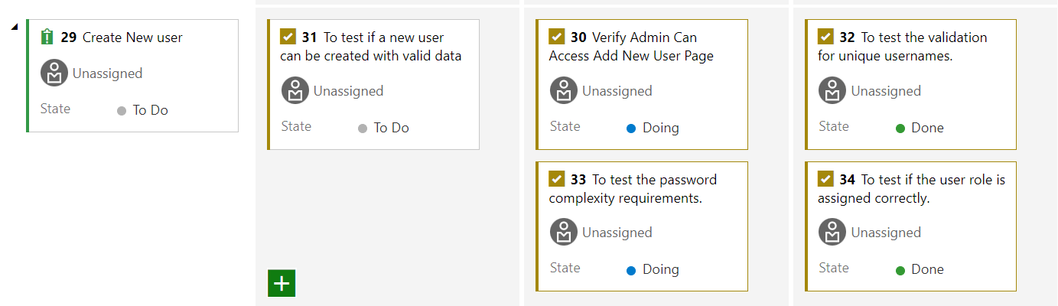

**User Story 5:**

As a user, when I go to Job Titles under Jobs dropdown in Admin tab, I should be able to add, edit, delete jobs.

**Acceptance Criteria**: When the user goes to Admin tab and clicks on Job titles under Jobs dropdown,

* The system should display all the jobs currently listed in the portal
* The system should allow the user to add a new job title with the description
* The system should allow the user to edit as well as delete existing job titles

Effort: 4

Priority: 2

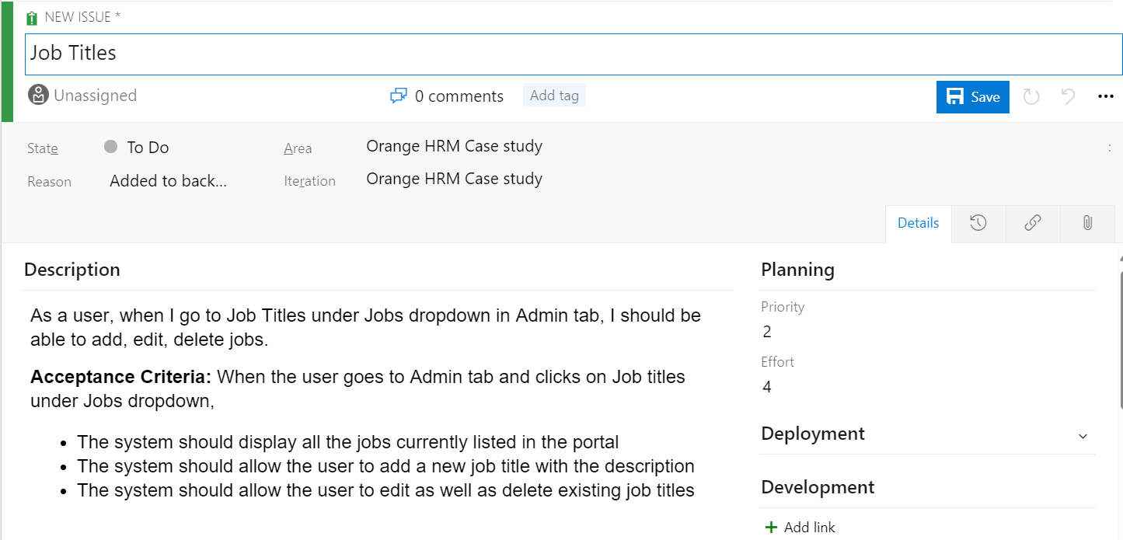

**Test Cases:**

TC_021: Verify Admin Can Access Job Titles Page

Description: To test if the Admin can access the Job Titles page.

Given the Admin can access the OrangeHRM application and logs in using admin username and admin_password password,  
When the Admin navigates to the Jobs section and clicks on the “Job Titles” option,  
Then the Admin should be able to view the Job Titles page.

TC_022: Verify Adding a New Job Title with Valid Data

Description: To test if a new job title can be added with valid data.

Given the Admin is on the Job Titles page,  
When the Admin clicks on the “Add” button, enters valid data (Job Title: Software Engineer, Job Description: Develops software applications, Job Specification: specification.pdf, Note: N/A) and clicks the “Save” button,  
Then the new job title should be added successfully and listed on the Job Titles page.

TC_023: Verify Job Title Duplication Validation

Description: To test the validation for duplicate job titles.

Given the Admin is on the Job Titles page,  
When the Admin clicks on the “Add” button, enters a job title that already exists (Job Title: Software Engineer, Job Description: Develops software applications, Job Specification: specification.pdf, Note: N/A) and clicks the “Save” button,  
Then the system should display an error message indicating that the job title already exists.

TC_024: Verify Editing an Existing Job Title

Description: To test if an existing job title can be edited.

Given the Admin is on the Job Titles page,  
When the Admin selects an existing job title (e.g., Software Engineer), clicks on the “Edit” button, modifies the job description (e.g., Develops and maintains software applications), and clicks the “Save” button,  
Then the job title should be updated successfully with the new details.

TC_025: Verify Deleting a Job Title

Description: To test if a job title can be deleted.

Given the Admin is on the Job Titles page,  
When the Admin selects an existing job title (e.g., Software Engineer), clicks on the “Delete” button, and confirms the deletion,  
Then the job title should be removed from the list and no longer visible on the Job Titles page.

